The Who, What, Where, and when of Programs

At the Bell Memorial Public Library

Mentone, IN.



November Edition

**Friday November 1st:**

Who: **LITTLES (3yrs-7yrs)**

What?: **Story Time & Craft** (Free of Charge)

Book: Autumn is Here

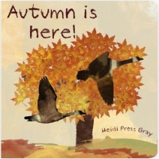

Fall books are a wonderful way to explore the seasons with your children. Celebrate the changing of the seasons with the book Autumn is Here! With full color watercolor illustrations and whimsical text, you and your child will explore all the different changes in nature and in family life as autumn approaches. Pick some apples, bake some muffins, watch the squirrels gather nuts, visit the farm and have a bonfire! Warm up some cinnamon tea and cuddle up with your child today to read a wonderful book about fall, Autumn is Here! (from the publisher's web site)

– excerpt from good**reads**—

Published: September 21, 2012 by CreateSpace Independent Publishing Platform

Craft:

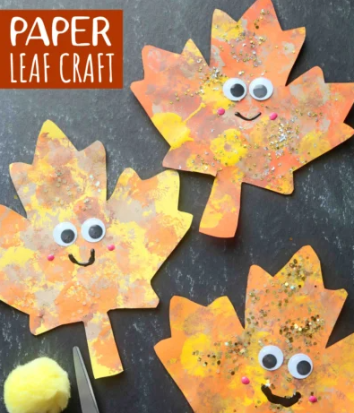

Where: Kids Room

When: Starts at 2pm

**Tuesday November 5th:**

Who: **TEENS (13yrs+)**

What?: **Tasty Tales and Treats**:(Free of Charge)

This is a fun and exciting opportunity to watch a book come to life on the LG Movie Screen while eating a YUMMY snack!!!!

Tale: **The Hobbit: Graphic Novel**

[**Chuck Dixon (Adapter)**](https://www.goodreads.com/author/show/28709.Chuck_Dixon)

[**J.R.R. Tolkien (Creator)**](https://www.goodreads.com/author/show/656983.J_R_R_Tolkien)**,** [**David Wenzel (Illustrator)**](https://www.goodreads.com/author/show/42156.David_Wenzel)**,** [**Sean Deming (Adapter)**](https://www.goodreads.com/author/show/150123.Sean_Deming)**,** [**Bill Pearson (Letterer)**](https://www.goodreads.com/author/show/171408.Bill_Pearson)**,** [**Charles Dixon (Adapter)**](https://www.goodreads.com/author/show/14219740.Charles_Dixon)

First published over 50 years ago, J.R.R. Tolkien's 'The Hobbit' has become one of the best-loved books of all time. Now Tolkien's fantasy classic has been adapted into a fully painted graphic novel.  
  
'The Hobbit' is the story of Bilbo Baggins…a quiet and contented hobbit whose life is turned upside down when he joins the wizard Gandalf and thirteen dwarves on their quest to reclaim the dwarves' stolen treasure. It is a journey fraught with danger – and in the end it is Bilbo alone who must face the guardian of this treasure, the most-dreaded dragon Smaug.  
  
Illustrated in full colour throughout, and accompanied by the carefully abridged text of the original novel, this handsome authorised edition will introduce new generations to a magical masterpiece – and be treasured by Hobbit fans of all ages, everywhere.

– excerpt from good**reads**--

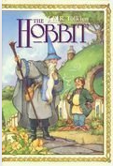

Treat: SHIREcuterie Board

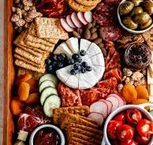

Where: Large Conference Room

When: 5pm-6pm

**Wednesday November 6th:**

Who: **ADULTS**

What?: **Cocoa and Canvas w/Lisa Bemish** ($15 due at event) ***REGISTRATION REQUIRED (20 participant limit)***

The Project:

Instructional painting on 11X14 canvases. ALL supplies provided!

Create a wonderful holiday keepsake while sipping on hot cocoa.

What could be better? Don’t miss out!

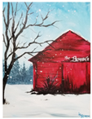

Where: Large Conference Room

When: 5-7pm

**Thursday November 7th:**

Who: **ALL WELCOME!**

What?: **Game Night** (Free of Charge)

Ever played Wii on a LARGE movie screen? After this, you can say you have! Join us for a fun evening of MARIO PARTY 8!!!!

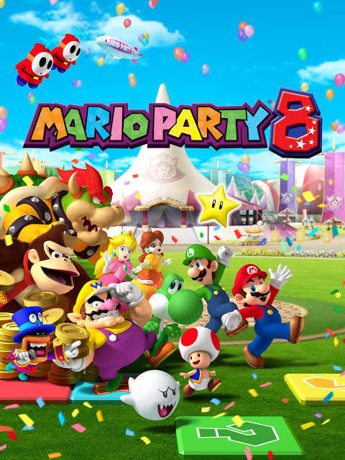

From the Nintendo Website - "Roll up, roll up! The carnival is in town and it's time to party! Join Mario, Luigi, Peach, Yoshi, DK and more of your favourite Nintendo characters as they compete across six game boards and more than 60 minigames to win the coveted prize: a year's supply of candy! But Bowser isn't about to let them get away with it…

For the first Mario Party on Wii, up to four players roll virtual dice and move around the game boards (ranging from a haunted house to a moving train and a treasure island) before competing in crazy minigames that make full use of the Wii Remote; such as tightrope walking, skipping, snowboarding, boat rowing, lassoing and even cake decorating”.

Where: YA Room

When: 4:30-6:30pm

**Friday November 8th:**

Who: **LITTLES (3yrs-7yrs)**

What?: **Story Time & Craft** (Free of Charge)

Book:

Find out how Native Americans introduced European settlers to corn and how it has become an important crop to people and animals around the world as you read The Story of Corn.

– excerpt from good**reads**--



Craft:

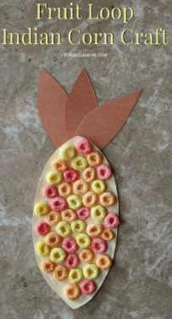

Where: Kids Room

When: Starts at 2pm

**Monday November 11th:**

Who: **ADULT (Senior Citizens-55&Older)**

What?: **Senior Movie Monday (w/POPCORN!)** (Free of Charge)

**Movie: *Breakfast at Tiffany’s***



**What’s it About?!?!?:**

***Breakfast at Tiffany's*** is a 1961 American [romantic comedy](https://en.wikipedia.org/wiki/Romantic_comedy) film directed by [Blake Edwards](https://en.wikipedia.org/wiki/Blake_Edwards) from a screenplay by [George Axelrod](https://en.wikipedia.org/wiki/George_Axelrod) and based on the [1958 novella of the same name](https://en.wikipedia.org/wiki/Breakfast_at_Tiffany%27s_(novella)) by [Truman Capote](https://en.wikipedia.org/wiki/Truman_Capote). It stars [Audrey Hepburn](https://en.wikipedia.org/wiki/Audrey_Hepburn), [George Peppard](https://en.wikipedia.org/wiki/George_Peppard), [Patricia Neal](https://en.wikipedia.org/wiki/Patricia_Neal), [Buddy Ebsen](https://en.wikipedia.org/wiki/Buddy_Ebsen), [Martin Balsam](https://en.wikipedia.org/wiki/Martin_Balsam), and [Mickey Rooney](https://en.wikipedia.org/wiki/Mickey_Rooney). In the film, Holly Golightly (Hepburn), a naïve, eccentric socialite meets Paul Varjak (Peppard), a struggling writer who moves into her apartment building.

–From WIKIPEDIA--

Where: Large Conference Room

When: Starts at 1pm

**Tuesday November 12th:**

Who: **JR’S (8-12yrs)**

What?: **Cook N Book** (Free of Charge)

This is a fun and exciting opportunity to watch a book come to life on the LG Movie Screen all the while eating a YUMMY snack that you have prepared!!!!

Cook: Mini Pizzas!

It's tough to be an out-of-work princess.  
  
After her royal father decides to retire and become a wood carver, Princess Paulina has no idea what to do with herself. She can't survey the kingdom from her leaky cottage roof, and no one waves back when she proceeds through the town on her father's cart.  
  
When she hears that a neighboring queen is seeking a bride for her son, Prince Drupert, Paulina sees her chance to get back to princessing.  But it will take all her wit and determination to pass the Queen's tests… and in the end, maybe there are better fates than a royal marriage.  
  
Full of tongue-in-cheek references to stories like Rapunzel, Snow White, and the Princess and the Pea, this fractured fairy tale is an hilarious twist on traditional tales in which a young woman's practicality, good humor, and intelligence let her shape her own happy ending— with extra cheese and all the toppings her heart desires. ---excerpt from goodreads



Book: Princess and the Pizza

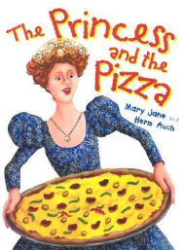

Where: YA Room

When: 5-6pm

**Tuesday November 12th:**

Who: **ADULT**

What?: **Adult Book Club** (Free of Charge)

**Book: *Before the Swallows Come Back***

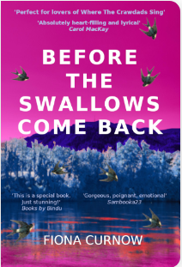

**Before the Swallows Come Back is a story of love, found family, and redemption that will break your heart and have it soaring time and time again as you sit on the edge of your seat desperately hoping.** Tommy struggles with people, with communicating, preferring solitude, drifting off with nature. He is protected by his Tinker family who keep to the old ways. A life of quiet seclusion under canvas is all he knows.  
  
Charlotte cares for her sickly father. She meets Tommy by the riverside and an unexpected friendship develops. Over the years it becomes something more, something crucial to both of them. But when tragedy strikes each family they are torn apart.  
  
Charlotte is sent far away.  
  
Tommy might have done something very bad.

–excerpt from good**reads**—

If interested in attending please contact [plancet@bell.lib.in.us](mailto:plancet@bell.lib.in.us)

Where: Maker Space

When: 5:30-7pm

**Thursday November 14th:**

Who: **JR’S (8-12yrs)**

What?: **LEGO Club** (Free of Charge)

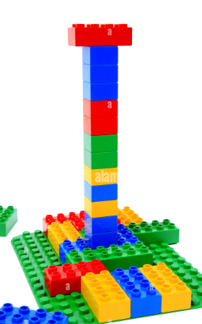

Each Month we provide a new LEGO Challenge. This month is Tower Building! Each participant will make a tower out of a specific number of blocks. Whose will be the tallest and most sturdy? The best part… may be trying to knock them down!!!! We’ll give it a jiggle, a wiggle and more! You won’t want to miss out on this one!!!!

Where: YA Room

When: 4:30-6pm

**Thursday November 14th:**

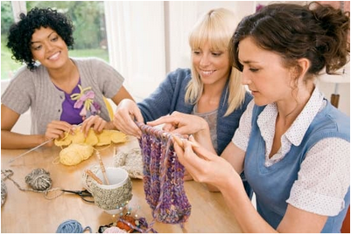

Who: **ADULTS**

What?: **ProCRAFTinators** (Free of Charge)

Have an “in progress” craft project? Bring it in!

Let’s socialize while working on it!

Where: Makers Space

When: 2-3pm

**Friday November 15th:**

Who: **LITTLES (3yrs-7yrs)**

What?: **Story Time & Craft** (Free of Charge)

Book: Alfie

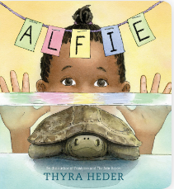

Nia loves Alfie, her pet turtle. But he’s not very soft, he doesn’t do tricks, and he’s pretty quiet. Sometimes she forgets he’s even there! That is until the night before Nia’s seventh birthday, when Alfie disappears!

Then, in an innovative switch in point of view, we hear Alfie’s side of the story. He didn’t leave Nia—he’s actually searching for the perfect birthday present for his dear friend. Can he find a gift and make it back in time for the big birthday party?

–From good**reads**--

Craft: CD & Button Turtle

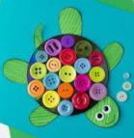

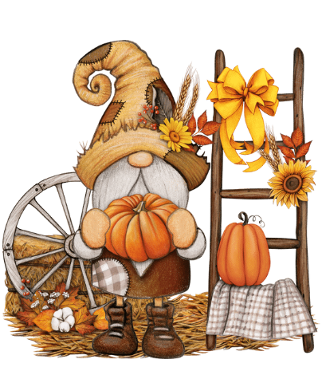

Where: Kids Room

When: Starts at 2pm



**Tuesday November 19th:**



Who: **ALL WELCOME!** (Free of Charge)

What?: **Color us Happy!**

Come for a little, or stay the whole time! Either way, LETS GET OUR COLOR ON!!!

You pick what you want to color (or choose one of our preprinted ones), we print it

for you, and then you color to your hearts content! We provide markers, colored

pencils, and crayons. OR, if you prefer, you can bring your own materials. 😊

Where: Large Conference Room

When: 4:30-6:30pm

**Thursday November 21st:**

Who: **JR’S (8-12yrs)** & **LITTLES (3yrs-7yrs)**

What?: **WACKY WARBLERS**

What is it exactly? **KARAOKE! -Disney Style!** (Free of Charge)





**Come Karaoke with us!**

**For your child’s convenience…**

**We have a list of Disney Songs to choose from AND we will (again) be projecting on the wall; in true “sing a long” fashion!**

**A great time is had by all!**



Where: Large Conference Room

When: 4:30-5:30pm

**Friday November 22nd:**

Who: **LITTLES (3yrs-7yrs)**

What?: **Story Time & Craft** (Free of Charge)

Book: Pete the Cat and the First Thanksgiving

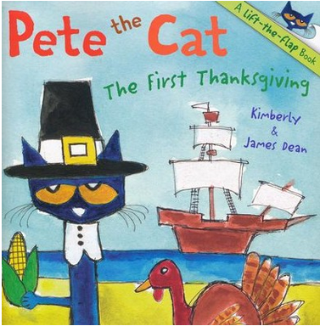

Starring in the school Thanksgiving play would make even the coolest cat nervous. But when Pete the Cat gets onstage, he makes learning the story of the first Thanksgiving fun. With thirteen flaps that open to reveal hidden surprises, this book is sure to be a holiday favorite for every Pete the Cat fan.

–Excerpt from -- https://www.christianbook.com/pete-the-cat-the-first-thanksgiving --

Craft: Thanksgiving Wreath

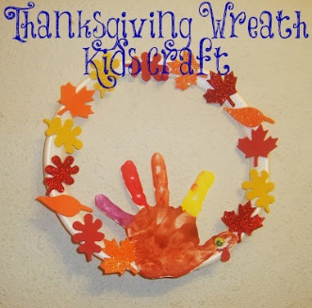

Where: Kids Room

When: Starts at 2pm

**Tuesday November 26th:**

Who: **ALL WELCOME!**

What?: **Cooking Club- Pancakes!** (Free of Charge)

***Any participating Littles MUST have an adult present***

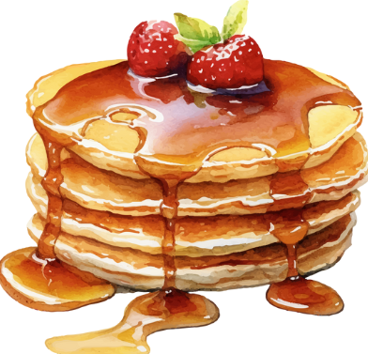

Have you ever wondered if homemade pancakes are really better than a store box mix?

Did you even know you could make HOMEMADE pancakes?

Well… You can! And WE will! YUUUMMMMMMMMMYYYYYYYYYYYYY! **\*\*\*Registration is required\*\*\***

Where: Large Conference Room

When: 4:30-6:30pm

**Friday October 28th & 29th:**



LIBRARY CLOSED

**Saturday November 30th:**

Who: **TEENS (13yrs+) & Adults** (Free of Charge)

What?: **Crafting Corner- 3D Paper Lanterns**

***Registration Required by November 18th***

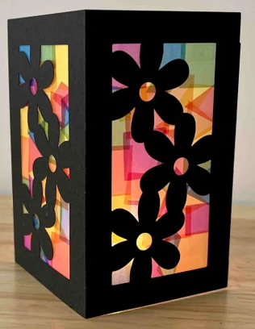

Come Craft w/ us. These customizable lanterns are adorable!

Will you do seasonal sides? One specifically for fall? Winter perhaps! My head spins!!!

The possibilities are endless!

***ATTENTION*** We WILL BE using the Cricut, come prepared!

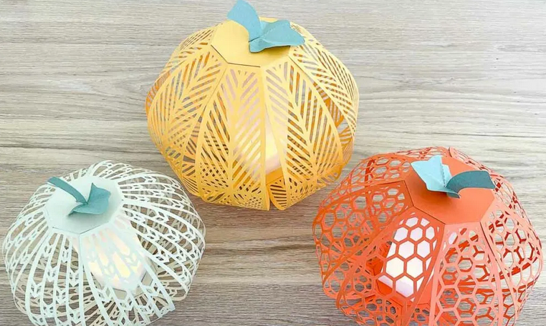

Actual project will vary from images. See SAMPLES by sign-up sheet

Where: Makers Space

When: 11am-1pm

**If you have any questions about the programs Bell Memorial Public Library (Mentone, IN) has, please reach out.**

Littles & Adults: Pat L. ([plancet@bell.lib.in.us](mailto:plancet@bell.lib.in.us))

Jr’s & Teens: Rachel J. ([rjohnson@bell.lib.in.us](mailto:rjohnson@bell.lib.in.us))

**574-893-3200**