New DVD’s coming soon

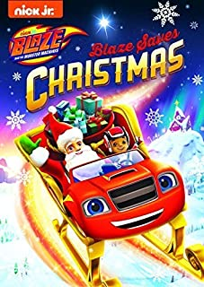 | 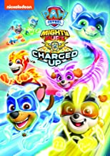
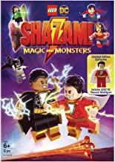  When the boy hero Shazam is offered to join the Justice League he is reluctant about it, but when his rivals the Monster Society put the League in peril he's the only one who can save them. | 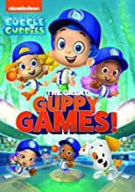
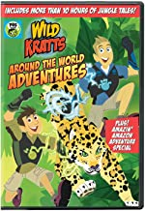 | 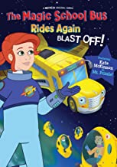  Ms. Frizzle and her class along with an inventive high-tech bus that invites children on high-flying hijinks that introduce the incredible world of science.
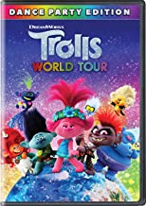  When the Queen of the Hard Rock Trolls tries to take over all the Troll kingdoms, Queen Poppy and her friends try different ways to save all the Trolls. | 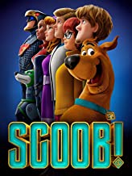  Scooby and the gang face their most challenging mystery ever: a plot to unleash the ghost dog Cerberus upon the world. As they race to stop this dogpocalypse, the gang discovers that Scooby has an epic destiny greater than anyone imagined.
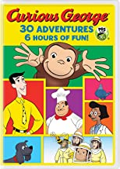 | 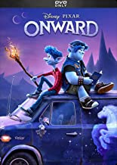  Two elven brothers embark on a quest to bring their father back for one day.
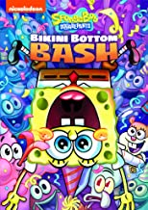 | 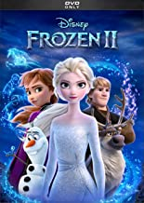  Anna, Elsa, Kristoff, Olaf and Sven leave Arendelle to travel to an ancient, autumn-bound forest of an enchanted land. They set out to find the origin of Elsa's powers in order to save their kingdom.
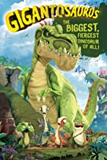
Four curious young dinosaur friends explore the mystery of Gigantosaurus, the largest, fiercest dinosaur of all, as they face their individual fears and work together to solve problems during their many adventures. Based on the book 'Gigantosaurus' by Jonny Duddle.

