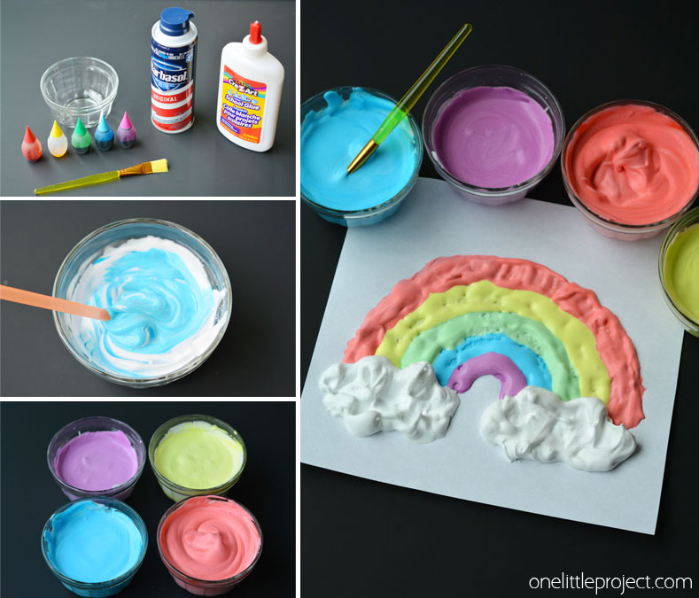
Make puffy paint at home...the kids will love it!
Kids love to paint! But have you ever made puffy paint for your kids? If you haven’t, this is a project you should definitely try! Puffy paint provides hours of fun for kids of any age. In case it’s new to you, this paint has texture that dries puffy and foamy to the touch. Your kids will love it! The kids can use the paint to decorate the sidewalk or driveway and the best part is that it washes off :)
Puffy Paint Recipe for Kids
First of all, you need a few things to get the best results:
1. Condiment bottles from Dollar Tree
2. A funnel
3. A large can of white shaving cream {not shave gel!}
4. One large bottle of plain white school glue
5. Liquid food coloring in desired colors
If you want to mix a few different colors, have a bowl ready for mixing each color, and a squirt bottle for each color.
Recipe:
1/2 cup of shaving cream
1/4 cup of white school glue
10-15 drops of food coloring
Put the shaving cream into the bowl first, then add the glue and carefully fold the two ingredients together. The goal is to keep as much of the air in the shaving cream as possible. Once you have mixed the two together, put food coloring in each bowl of puffy paint and carefully fold it in. Keep in mind that as the paint dries, it gets darker.
Once you mix your colors, pour each color into a squirt bottle using a funnel. Use a straw if necessary to help the paint flow down through the funnel. Now you can use your bottles of puffy paint to create lots of pretty designs!

